Experiment 1 – Introduction to HTML
Objective
- Introduction to HTML language.
HTML is a language for describing web pages.
- HTML stands for Hyper Text Markup Language
- HTML is not a programming language, it is a markup language
- A markup language is a set of markup tags
- The purpose of the tags are to describe page content
HTML Tags
HTML markup tags are usually called HTML tags
- HTML tags are keywords (tag names) surrounded by angle brackets like <html>
- HTML tags normally come in pairs like <b> and </b>
- The first tag in a pair is the start tag, the second tag is the end tag
- The end tag is written like the start tag, with a forward slash before the tag name
- Start and end tags are also called opening tags and closing tags
Web Browsers
The purpose of a web browser (Chrome, Internet Explorer, and Firefox) is to read HTML documents and display them as web pages. The browser does not display the HTML tags, but uses the tags to interpret the content of the page.
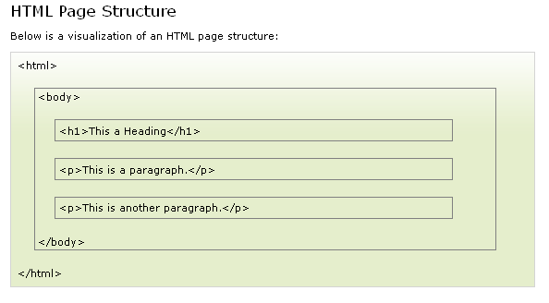
HTML Element
- An HTML element starts with a start tag / opening tag
- An HTML element ends with an end tag / closing tag
- The element content is everything between the start and the end tag
- Some HTML elements have empty content
- Empty elements are closed in the start tag
- Most HTML elements can have attributes
HTML Headings
<h1>Check this out</h1>
<h2>What you think of it now</h2>
<h3>And what about now</h3>

HTML Paragraphs
<p>This is a paragraph.</p>
<p>This is another paragraph.</p>
Use the <br /> tag if you want a line break (a new line) without starting a new paragraph

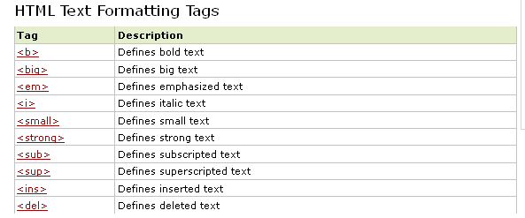

HTML Lists
An unordered list starts with the <ul> tag. Each list item starts with the <li> tag.
The list items are marked with bullets (typically small black circles).
<ul>
<li>EE</li>
<li>CS</li>
<li>BBA</li>
</ul>
HTML Images

<img src="temp.jpg" width="250" height="142" />
<img src="cloud.jpg" alt="Cloud" />
To display an image on a page, you need to use the src attribute. Src stands for "source". The value of the src attribute is the URL of the image you want to display. The height and width attributes are used to specify the height and width of an image.
The URL points to the location where the image is stored. An image named "boat.gif", located in the "images" directory on "www.google.com" has the URL: http://www.google.com/images/boat.gif.
HTML Links
A hyperlink (or link) is a word, group of words, or image that you can click on to jump to a new document or a new section within the current document. When you move the cursor over a link in a Web page, the arrow will turn into a little hand.
Links are specified in HTML using the <a> tag.
The <a> tag can be used in two ways:
- To create a link to another document, by using the href attribute
- To create a bookmark inside a document, by using the name attribute
<a href="http://www.google.com">This is a link</a>
<a href="http://www.google.com/" target="_blank">Google Karo</a>

The target attribute specifies where to open the linked document.
The name attribute specifies the name of an anchor.
The name attribute is used to create a bookmark inside an HTML document.

Using Images as HTML Links
To use an image as a link, you will have to use two things you have already learned.
1. How to create a link.
2. How to add an image to the page.
<a href="http://www.google.com">
<imgsrc="sunset.jpg">
</a>

Linking Within a Single Page
Maybe you would like to give someone a way back to the top of the page when they are at the bottom. Or maybe you want to divide it into sections and use a table of contents at the top. Well, the way to do this is to use a named anchor, which is a specific area of your page you want to make a link to. You could link to any part of the page, but for now, let's say you want to create a link to the top of your page. To do this, go to the top of the body section (right after the body tag). Now type the following tag:
<a name="top"></a>
You can place any name you wish inside the quotes. This just makes it easy to see where we are going to end up. Now, go anywhere between the body tags and type this link:
<a href="#top">Back to the Top</a>
If you click on this link, you will be sent back to the top of the page.
HTML Tables
Tables are defined with the <table> tag.
A table is divided into rows (with the <tr> tag), and each row is divided into data cells (with the <td> tag). td stands for "table data," and holds the content of a data cell. A <td> tag can contain text, links, images, lists, forms, other tables, etc.
If you do not specify a border attribute, the table will be displayed without borders. Sometimes this can be useful, but most of the time, we want the borders to show.
Header information in a table are defined with the <th> tag.
<table border="1">
<tr>
<th>Department</th>
<th>Course</th>
</tr>
<tr>
<td>CS</td>
<td>Data Structure</td>
</tr>
<tr>
<td>EE</td>
<td>Circuit Analysis</td>
</tr>
</table>

INPUT Control

- Input(Text)
<input id="Text1" type="text" value="Please Enter City" />

- Input(Password)
<input id="Password1" type="password" value="dummy" />

- Input(Checkbox)
<input id="Checkbox1" type="checkbox" checked="true" />

- Input(Radio)
<input id="Radio1" type="radio" checked="true" />

- Input(Button)
<input id="Button1" type="button" value="button" />

Exercise 1: Create a first page “firstpage.html”

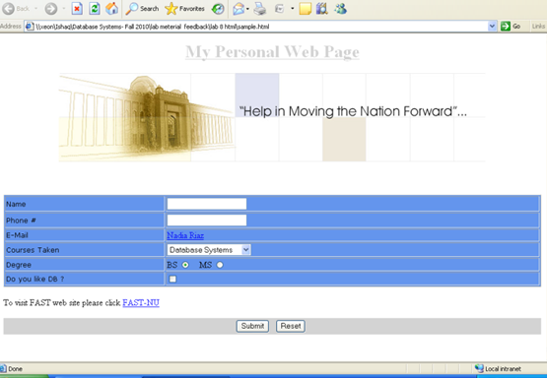

Good Reference:

http://www.w3schools.com

Post lab
- Design a webpage for a sports website using HTML only. Use your imagination and be innovative. For help explore w3schools.
- Find and list the differences between HTML version 3 and HTML version 5.

